 |  | Extend is the place for your children to thrive, learn and play, so what are you waiting for? Book and enrol at www.extend.com.au
 |  | Hours of Operation  After School Care: 3:00pm - 6:00pm  Holiday Care: 7:00am - 6:00pm  Note: Before School Care (Only On Thursdays) : 7.00am - 8.15am |  |  |  | Contact Details  0474 911 443  spadelaide@extend.com.au
Monday | Tuesday |  |  | Wednesday | Thursday |  |  | Friday
MasterChef Kitchen Deli | Dodge Those Balls |  |  | Art & Craft Coloring & Decoration | Trivia and Fun Facts |  |  | Dribble, Shoot and Win
Monday | Tuesday |  |  | Wednesday | Thursday |  |  | Friday
Crazy Science Day | Water Colour Magic |  |  | Upbuild and Recycle | Midi & Mini Hama Beads Design Inspiration |  |  | Pass,Shoot & Score
DISCOVER |  |  | LEARN |  |  |  | PLAY
 |  |  |  |  |  |  | 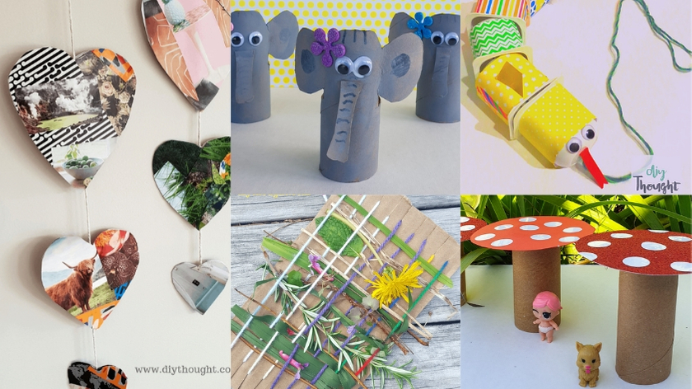
Duck, Duck, Goose teaches children to plan ahead and gives them immediate feedback on the quality of their decisions |  |  | Hama Beads will help them learn to count, match colours and recognise geometric shapes. |  |  |  | Recycle.: A hands-on activity that shows how different kinds of materials decompose will help bring the concept to life.
STAR OF THE WEEK!  Lucas  For being so helpful in tidying up for his OSHC Area. Keep up the great work! |  |  | Thank you to all the wonderful children who came to the service with big smiles and full of energy. Join us at the service for some awesome and messy science experiments and delicious healthy treats.  Namita Mehta  Service Coordinator

